CST8002 Programming Language Research Project

# Hybrid Activity 06 – Responsible Use of AI as Learning Resource

**See Brightspace for Due Date**

**Refer to the Weekly Schedule document posted in Brightspace under Course Information for additional requirements common to all assessments.**

## Overview

* Review the learning materials referenced and/or located here.
  + The Impact of AI on Computer Science Education
  + How to use AI to learn a new language
* Take the Hybrid 04 Quiz in Brightspace before the due date.

## Tasks

### The Impact of AI on Computer Science Education

Review the Communications of the ACM article [1] via the ACM Digital Library in the school library:

Esther Shein. The Impact of AI on Computer Science Education. Communications of the ACM. September 2024. Vol. 67. No. 9. pp 13 to 15.

* The Communications of the ACM is available in the ACM Digital Library in our Library now for free to students. [https://algonquincollege.libguides.com/az.php?a=a](https://can01.safelinks.protection.outlook.com/?url=https%3A%2F%2Falgonquincollege.libguides.com%2Faz.php%3Fa%3Da&data=05%7C02%7Cpiedas%40algonquincollege.com%7C2deeabae3c834a34561208dc9218477f%7Cec1bd9240a6a4aa9aa89c980316c0449%7C0%7C0%7C638545880176710253%7CUnknown%7CTWFpbGZsb3d8eyJWIjoiMC4wLjAwMDAiLCJQIjoiV2luMzIiLCJBTiI6Ik1haWwiLCJXVCI6Mn0%3D%7C0%7C%7C%7C&sdata=xBMW6%2FXlvl9BxLB5ltN52KabcZFtMzkjKqlyW7eEkd8%3D&reserved=0)
* Specific link to the Journal volume:   
  <https://dl-acm-org.algonquin.idm.oclc.org/toc/cacm/2024/67/9>

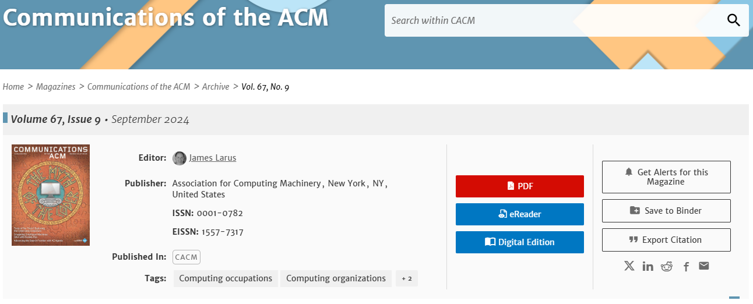

The pdf for the specific article is also available in Brightspace in the Hybrid 04 content area.

You will be asked one to more quiz questions based on the article.

### How to use AI to learn a new language

See the following articles [2][3][4] on how to use AI coding tools to learn a new language:

[2] <https://github.blog/developer-skills/programming-languages-and-frameworks/how-to-use-ai-coding-tools-to-learn-a-new-programming-language/>

[3] <https://www.theregister.com/2024/01/27/ai_coding_automatic/>

[4] <https://www.infoworld.com/article/2337313/learn-a-programming-language-using-ai.html>

* You will be asked at least one to more quiz questions on using AI as a learning resource.

## Grading (10 Points Total)

* Hybrid Quiz 06 – 10 questions, 1 point per question.

# References / Sources Cited / Resources:

[1] Esther Shein. The Impact of AI on Computer Science Education. Communications of the ACM. September 2024. Vol. 67. No. 9. pp 13 to 15.

[2] Sara Verdi. (August 7, 2024). How to use AI coding tools to learn a new programming language. github.blog. [online] Available at: <https://github.blog/developer-skills/programming-languages-and-frameworks/how-to-use-ai-coding-tools-to-learn-a-new-programming-language/> [Accessed on Nov 29, 2024]

[3] Katyanna Quach. (Jan 27, 2024). If you use AI to teach you how to code, remember you still need to think for yourself. theregister.com. [online] Available at: <https://www.theregister.com/2024/01/27/ai_coding_automatic/> [Accessed on Nov 29, 2024]

[4] Khalid Abuhakmeh. (May 20, 2024). How to learn a programming language using AI. infoworld.com. [online] Available at: <https://www.infoworld.com/article/2337313/learn-a-programming-language-using-ai.html> [Accessed on Nov 29, 2024]